

**Artificial intelligence project -: ping pong game**

Submitted to-: submitted by: -

Mr. SAGAR PANDEY chandrashekhar kairamkonda

Roll no-15

Ajit kumar yadav

Roll no-05 group k18gx(G1)

**Abstract**

Pong is a classic game, a very abstract version of Ping-Pong, where two paddles attempt to reach a ball before it falls off the table.

all the files that are necessary to the game. It is multiplayer ping pong game build on turtle module. where two persons can play this game. you can simply run the file to play the game by downloading

the game is look something like this

before the creation

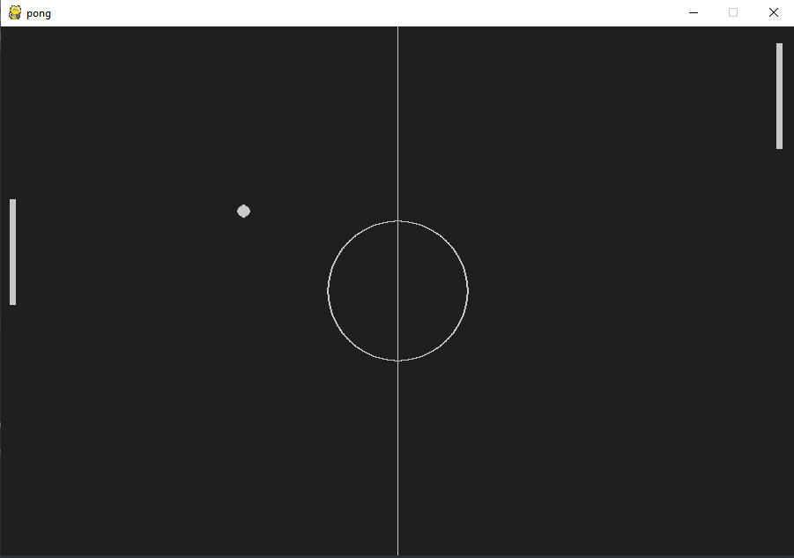

**Introduction**

**Pong is a simple game, so we can provide a computer AI with a simple 2-part strategy:**

* Model reaction time - wait some period before making decisions.
* Model accuracy - the computer knows exactly where the ball will land, add a random error factor to pretend that the computer is fallable.

A fairy simple Pong game to help you learn the basics of Pygame.

Pygame is a cross-platform set of Python modules designed for writing video games. It includes computer graphics and sound libraries designed to be used with the Python programming language.

**Table tennis**, also called (trademark)**Ping-Pong**, [ball](https://www.britannica.com/sports/ball-sports) game similar in principle to [lawn tennis](https://www.britannica.com/sports/tennis) and played on a flat table divided into two equal courts by a [net](https://www.britannica.com/technology/net) fixed across its width at the middle. The object is to hit the ball so that it goes over the net and bounces on the opponent’s half of the table in such a way that the opponent cannot reach it or return it correctly. The lightweight hollow ball is propelled back and forth across the net by small [rackets](https://www.britannica.com/sports/rackets) (bats, or paddles) held by the players. The game is popular all over the world. In most countries it is very highly organized as a competitive sport, especially in [Europe](https://www.britannica.com/place/Europe) and Asia, particularly in [China](https://www.britannica.com/place/China) and [Japan](https://www.britannica.com/place/Japan).

**History**

The game was invented in England in the early days of the 20th century and was originally called Ping-Pong, a trade name. The name table tennis was adopted in 1921–22 when the old Ping-Pong Association formed in 1902 was revived. The original association had broken up about 1905, though apparently the game continued to be played in parts of England outside London and by the 1920s was being played in many countries. Led by representatives of [Germany](https://www.britannica.com/place/Germany), Hungary, and England, the Fédération International de Tennis de Table (International Table Tennis Federation) was founded in 1926, the founding members being England, [Sweden](https://www.britannica.com/place/Sweden), Hungary, India, Denmark, Germany, Czechoslovakia, [Austria](https://www.britannica.com/place/Austria), and Wales. By the mid-1990s more than 165 national associations were members.

The first world championships were held in London in 1926, and from then until 1939 the game was dominated by players from central Europe, the men’s team event being won nine times by Hungary and twice by Czechoslovakia. In the mid-1950s Asia emerged as a breeding ground of champions, and from that time the men’s team event has been won by either Japan or China, as has the women’s event, though to a lesser extent; [North Korea](https://www.britannica.com/place/North-Korea) also became an international force. In 1980 the first World Cup was held, and Guo Yuehua of China won the $12,500 first prize. Table tennis became an [Olympic](https://www.britannica.com/sports/Olympic-Games) sport in 1988, with singles and doubles competition for men and women.

1. **Motivation: -** As Pygame and the SDL library are portable across different platforms and devices, they both need to define and work with abstractions for various hardware realities. Understanding those concepts and abstractions help design and develop us our own game.
2. **Objective: -**

**multiplayer**

The overall objective of the game of ping-pong is to win the match by winning enough points to win more than half of the number of maximum possible games to be played between you and your opponent (in singles), or you, your partner and your two opponents (in doubles).

**Levels**

When one player wins continued game then that player will go to another level as the players wins level by level the speed of the ball also increases that makes this game very interesting for that you need to have fast hands as well as sharp eyes.

**Related work**

**Library’s used: -**

**Pygame: -** Pygame is a cross-platform set of Python modules designed for writing video games.

**Sys**: -The sysmodule provides information about constants, functions and methods of the Python interpreter.

**random: -** Functions in the random module depend on a pseudo-random number generator function random (), which generates a random float number between 0.0 and 1.0.

**THE GAME**

**The game will be played between manually control person and artificial which is opponent in the sense**

**The controls for the manually control person are down arrow for below the moving wall and up arrow for up the moving wall**

**Study the psychomotor coordination required to execute a successful ping pong serve**

Serve The ball and racket must be behind and above the table during the serve. From the upturned palm of the server's motionless free hand, the ball is tossed upward and struck as it falls so that it first hits the server's half of the table, travels over (or around) the net, and then hits the opponent's half of the table.

**Notice how the table tennis player drives through the shot to achieve spin over speed**

Forehand drive the drive is executed close to the table so the ball may be struck at the peak of its arc. The object is speed instead of spin, so the player hits through the ball, which is directed slightly downward over the net in a low arc.

**Study how the table ping pong player imparts topspin by brushing the ball's upper half with a closed racket face**

Forehand loop shots are executed away from the table and when the ball is on its way down. The player swings upward while "brushing" or grazing the upper half of the ball with a closed racket face (the top of the blade tipped toward the net). This imparts topspin to the ball.

**Observe the open racket face required to execute a forehand chop in ping pong**

Forehand chop the forehand chop is executed away from the table and when the ball is on its way down. The player, standing in a square-on position, swings downward while "brushing" or grazing the lower half of the ball with an open racket face (the top of the blade tipped away from the net). This imparts backspin to the ball. A quick, smooth follow-through is desirable.

**Study how to execute a downward graze to impart backspin with a ping pong backhand chop**

backhand chop is executed away from the table and when the ball is on its way down. The player, in a half-turn stance, swings downward while "brushing" or grazing the lower half of the ball with an open racket face (the top of the blade tipped away from the net). This imparts backspin to the ball. A quick, smooth follow-through is desirable.

**Rules of ping pong game**

For each game, the first player to reach 11 points wins that game, however a game must be won by at least a two-point margin. A point is scored after each ball is put into play (not just when the server wins the point as in volleyball). The edges of the table are part of the legal table surface, but not the sides.

**Implementation**

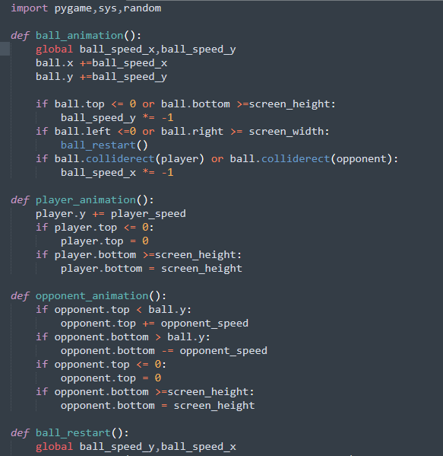

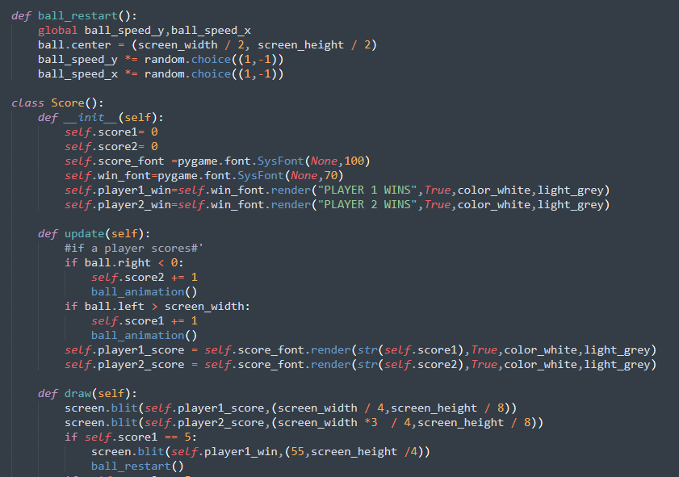

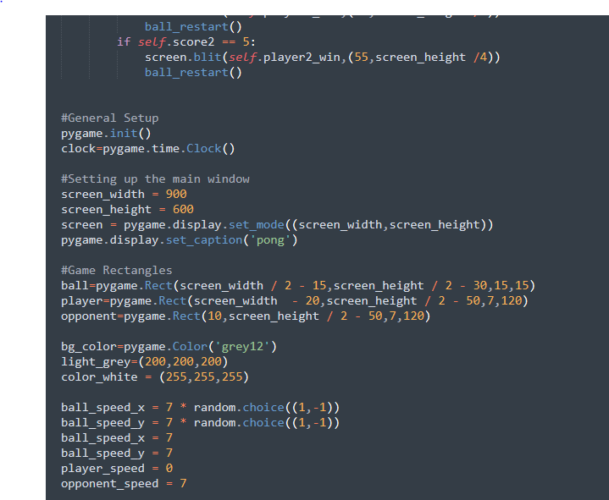

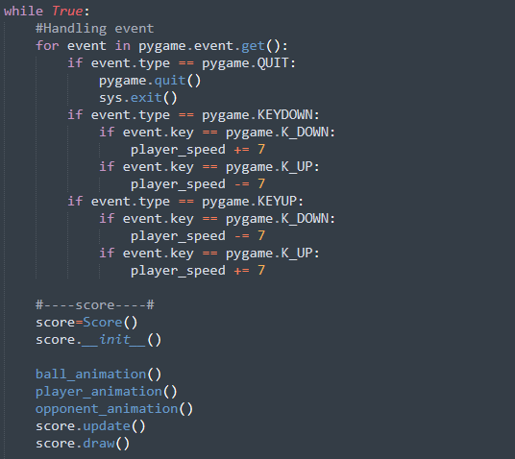

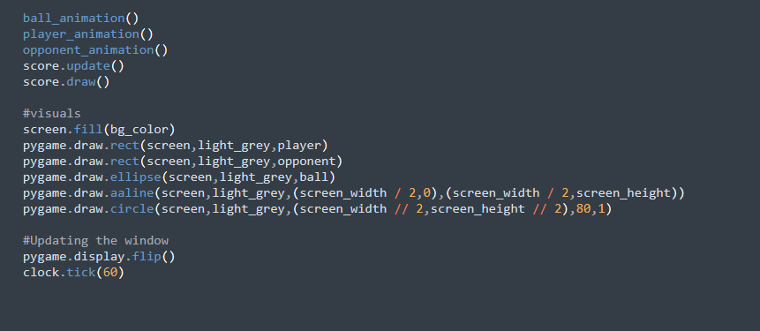

**After creation**

